**POOJA STORE**

1. First take an instance and inatall java,docker,git
2. After installing in server the we should clone with the source code

3 git clone <https://github.com/veeraboinaashok/Poojastore.git>

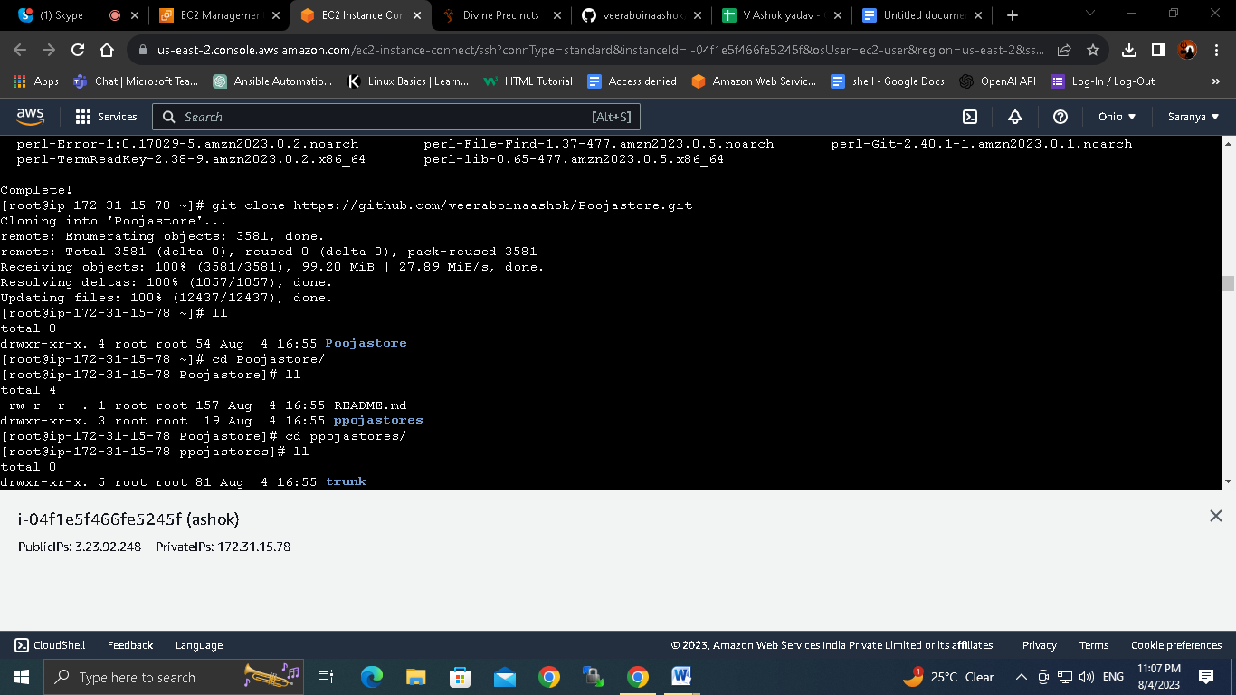

Then we should go to pooja store directory and write dockerfile and env file

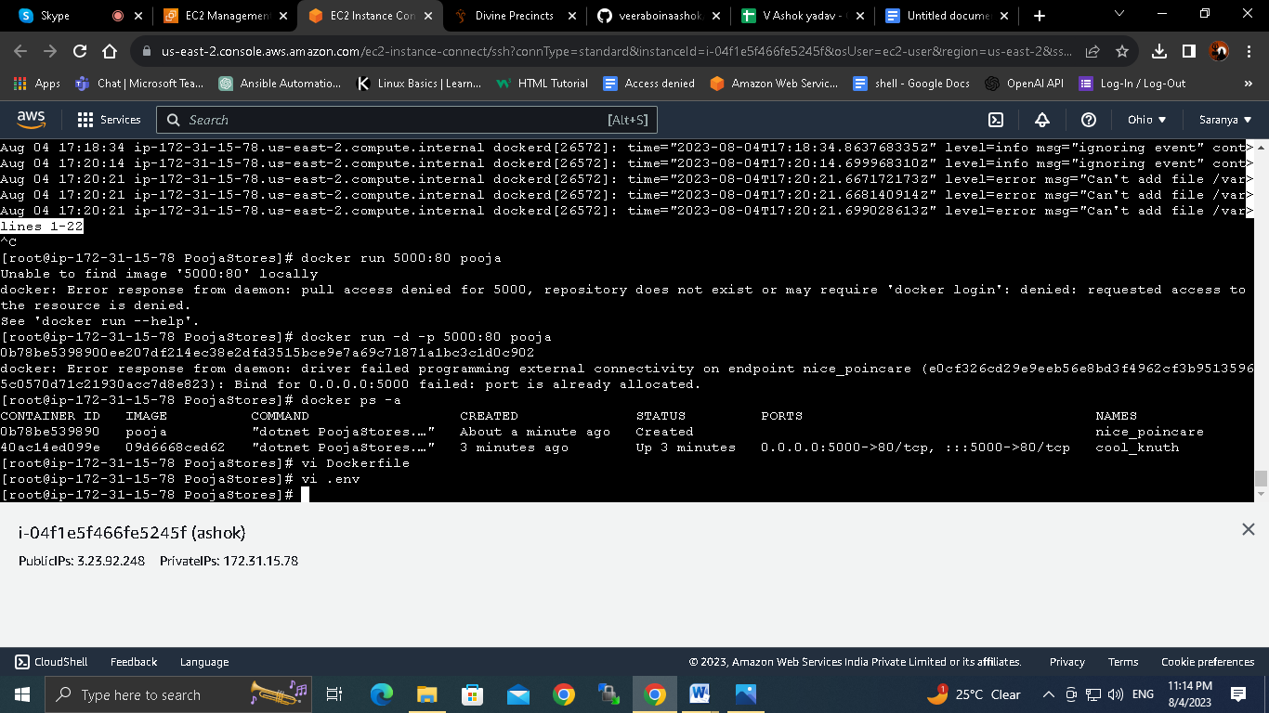

Docker file

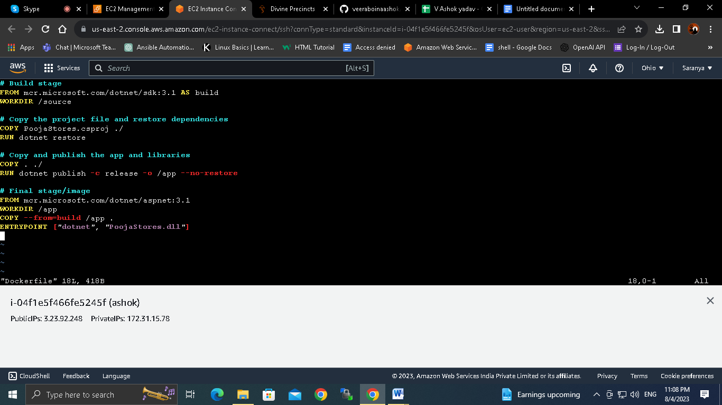

Env file

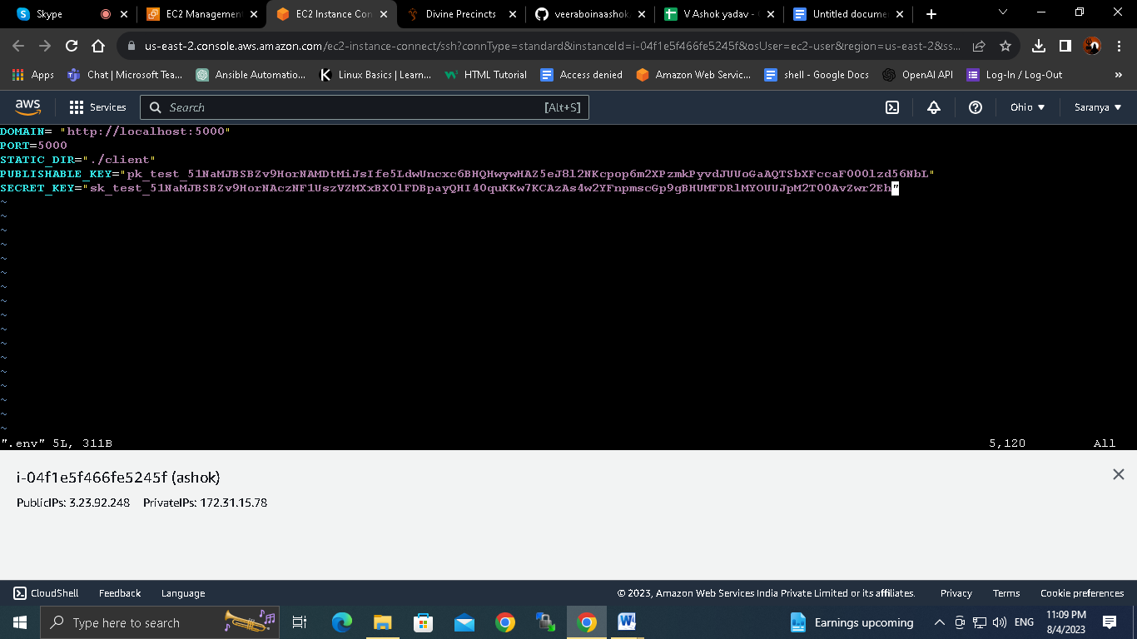

After creating dockerfile and env file we should run the dokcer file and create a image

docker image : docker build -t pooja .

after creating image then we should run the container

docker run -d -p 5000:80 pooja

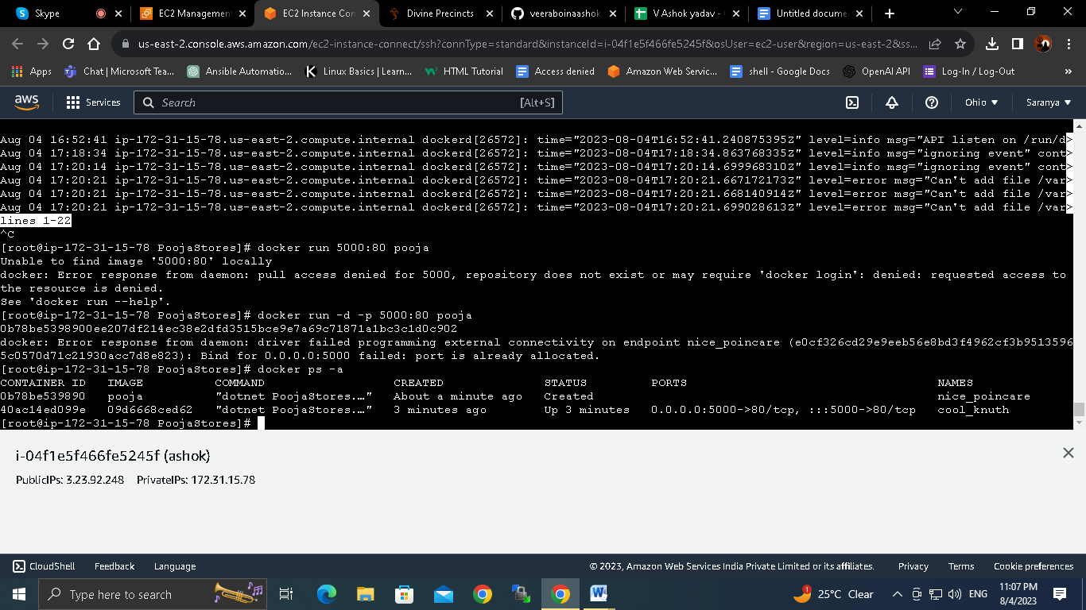

After running image we will get a container id

0b78be5398900ee207df214ec38e2dfd3515bce9e7a69c71871a1bc3c1d0c902

After container id appears the we should take public id and with port number 5000 and we will open pooja store website

Out put



10. And we should run the container with the commanddocker run -d -p 5000:80 pooja -store

11. out put